Younis Salma

***Analysis:***

**Problem Identification:**

Currently, there are very few or even no ways to play a Two-Player Tetris without spending money. However, spending money on a casual game like Tetris is often not worth it for most people. The average customer and my target audience, Casual gamers from the age range of 14-24, will rarely want to spend money to play this kind of game which leads to potential customers that have lost interest in the game.

Competitive Tetris aims to bring in a competitive edge to Tetris with the addition of a login system to maintain score and points with each time you play, which includes a leader boards system where your scores are taken from a database and compared and ordered.

**Stakeholders:**

As mentioned earlier, the clients/customers for this game would be casual gamers who have access to a computer.

**Primary Audience:**

My target primary audience ranges from age 14-20. I have chosen the range from 14 because this is generally the age where children gain access to games via a home computer, library or even a personal computer. From ages 14-18, customers are generally in education and often look towards games as a distraction/ a way of escaping the stress of school.

**Secondary Audience:**

My secondary audience ranges from 11-14 as well as 21-30. I have chosen 11-14 because although there is a small player base of this age, I must still include it as a secondary audience as this age is also keen to play casual/2player 1 keyboard games.

The stakeholders for the casual gaming demographic are Marce Ricketts and Daniel Byrne, both being experienced gamers who enjoy casual gaming.

**Why it is suited to a computational solution:**

The solution will be Tetris that has no money requirement and allows for 2 player while also obtaining a competitive edge that many Tetris games have failed to achieve. This will need to run on a computer simply because the game is meant to be played with a keyboard. There is no alternative solution which does not require a computer.

**Computational methods that the solution lends itself to:**

**Problem recognition:**

The overall problem is the lack of competitiveness and accessibility to the majority of Tetris games. The UI is generally hard to follow and doesn’t leave the player satisfied. The underlying problem is allowing for 2 separate games running at the same time both obtaining inputs from the same keyboard. There is also a problem with connecting a database with a game.

**Problem decomposition:**

The problem can be decomposed into a set of steps.

*The 2 Player system:*

1. Initially coding two separate screens, and running two separate games at once.
2. Merging both screens into once and splitting down the middle.
3. Setting specific key binds to each side of the keyboard for each player which can be changed in controls.

*The database and game connection:*

1. Each log on will have a unique id that will be linked to their data.
2. Scores and information will be linked to this id and will be fetched by looking up the id.
3. After finishing a game or logging off the data will remain in the file.
4. Leader boards will be updated depending on what information changes in the database.

**Divide and conquer:**

The problem itself is challenging and tricky to approach let alone solve, however when broken down into a small number of steps, it becomes much easier to handle and manageable allowing for a divide and conquer method of problem-solving.

**Abstraction:**

**Interview:**

**Interview Questions:**

I will outline some of the key questions that I will ask each stakeholder, I may ask for elaborations on answers depending on how they reply. The questions will aim to find out third opinions on the game.

**Casual Gaming:**

My questions for Marce and Daniel (who represent casual gaming) are as follows:

1. Have you played Tetris? If so, what are your thoughts on your experience?
2. What would you add to Tetris to make it a more enjoyable experience?
3. What is your opinion on free games vs games that cost?
4. What do you think about playing 2 player on 1 keyboard?
5. Do you think the addition of a login system would help and why?

Question 1 is to establish a history with this game. This is important as it allows me to compare and analyse what there is to improve.

Question 2 is to see if there are improvements that should be made to previous Tetris games. This allows me to implement things that I think are beneficial depending on what my stakeholders say.

Question 3 is to get some insight into their opinions on free games and non-free games which allow me to understand the difference between them and the importance of each other.

Question 4 is to get some understanding of the experiences they’ve had with 2 player 1 keyboard games.

Question 5 allows me to decide on the importance of a login system and which ways it helps.

**Interview:**

**Casual gaming – Marce**

1. **Have you played Tetris? If so, what are your thoughts on your experience?**

“”

1. **What would you add to Tetris to make it a more enjoyable experience?**

“”

1. **What is your opinion on free games vs. games that cost?**

“”

1. **What do you think about playing 2 players on 1 keyboard?**

“”

1. **Do you think an addition of a login system would help and why?**

“”

**Casual gaming – Daniel**

1. **Have you played Tetris? If so, what are your thoughts on your experience?**

“”

1. **What would you add to Tetris to make it a more enjoyable experience?**

“”

1. **What is your opinion on free games vs. games that cost?**

“”

1. **What do you think about playing 2 players on 1 keyboard?**

“”

1. **Do you think an addition of a login system would help and why?**

“”

**Analysis**

##################

**Research**

**Existing similar product:**

**“Tetris 99 – Nintendo Switch”**

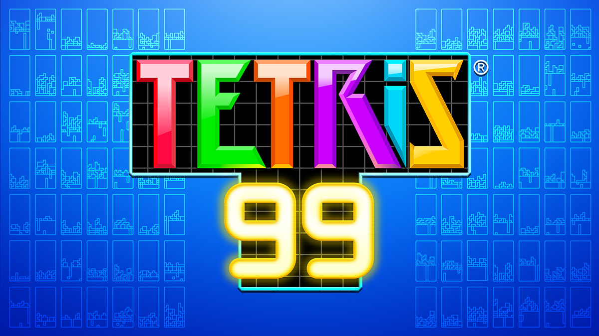

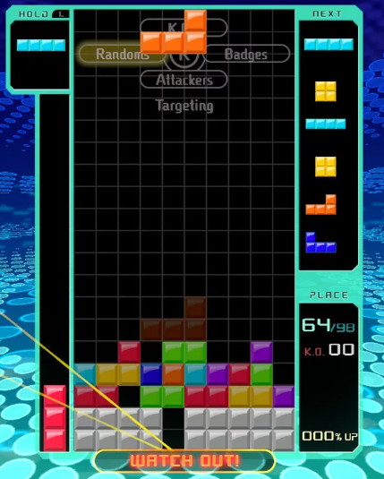

Tetris 99 is a multiplayer puzzle game in which 99 players play against each other at the same time (Battle Royal).

Tetris 99 is roughly £25 and is exclusive to the Switch from Nintendo.

“It's classic Tetris at its core, but with a new layer of risk-and-reward strategy in where you send your attacks” - IGN

“Tetris 99 often feels like a lot to handle, especially when the speed increases at the top-50 and top-10 marks” – IGN

**Pros and Cons:**

Tetris99 achieves a sense of competitiveness without a doubt and manages scoring very well, e.g. defeating someone leads to you stealing their multiplier boosting your score further. Its online play is fun and encourages replayability.

However, Tetris99 is not only £25 but is also exclusive to the Nintendo switch. As I have mentioned, this lack of accessibility causes potential customers to lose interest. I aim to obtain this competitive feel without having accessibility issues holding my game down to a smaller audience.

#

**Features of my proposed solution:**

**Initial concept of my solution considering this research:**

**Simple set of instructions:**

1. Open a client where customers can sign in or sign up.
2. Select a button from this list:

Introduction (where players will learn how the game works and controls)

New Game (where players can start a new game)

* Single-player or Two-player (where players decide if they want to play single player or not)

Leader boards (where players can view other players best scores from the database)

Settings (where players can change audio, resolution or view controls)

Current Best Score (where players can view the current best score)

Exit (where players can exit the game)

**Limitations of my solution:**

#####################

Further meeting with stakeholders:

This is an email that I sent to my stakeholders (Marce and Daniel):

“Hi,

I've been looking at ways I can make the software UI and I have come up with some specific ideas and plans I may implement, and I would appreciate your input. When the game starts, it will open up a screen with a size of 1280 x 720. It will ask for you to sign in or sign up if you haven't. Once signed in, you will be greeted with the main menu where the following buttons will be: Introduction, New Game (which will split into Single and 2 player), Leader boards, Settings, and Exit. It will also have your score displayed on the side. The system requirements for this game are very minimal and shouldn’t need to be considered. What do you think?

Thanks,

Younis”

The responses I received:

**Marce:**

“”

**Daniel:**

“”

**Requirements**

**Software and hardware requirements**

System Requirements:

OS: Windows 7 SP1, Windows 8/8.1, Windows 10 (32/64bit versions)  
Processor: Intel Core 2 Duo E7300 @ 2.5 GHz or AMD Athlon II X2 240 @ 2.8 GHz  
Memory: 2 GB RAM  
Graphics: Nvidia GeForce GTS450 or AMD Radeon HD5670  
Sound Card: DirectX Compatible Sound Card with latest drivers

**Hardware:**

Keyboard (for inputting and navigation),

Mouse (for navigation),

Monitor (for display),

Speakers (for audio).

**Software:**

Python interpreter (Code is written in python),

Import Pygame (Code uses Pygame).

**Stakeholder requirements**

**Design**

|  |  |
| --- | --- |
| **Requirement** | **Explanation** |
|  |  |
|  |  |
|  |  |
|  |  |
|  |  |
|  |  |
|  |  |
|  |  |
|  |  |
|  |  |
|  |  |
|  |  |
|  |  |
|  |  |
|  |  |
|  |  |
|  |  |

**Functionality**

|  |  |
| --- | --- |
| **Requirement** | **Explanation** |
|  |  |
|  |  |
|  |  |
|  |  |
|  |  |
|  |  |
|  |  |
|  |  |
|  |  |
|  |  |

**Hardware and Software**

|  |  |
| --- | --- |
| **Requirement** | **Explanation** |
|  |  |
|  |  |
|  |  |
|  |  |
|  |  |
|  |  |
|  |  |
|  |  |
|  |  |

**Success Criteria**

|  |  |
| --- | --- |
| **Criteria** | **How to evidence** |
|  |  |
|  |  |
|  |  |
|  |  |
|  |  |
|  |  |
|  |  |
|  |  |
|  |  |
|  |  |
|  |  |
|  |  |
|  |  |
|  |  |
|  |  |
|  |  |

**Design Prototypes**

**Login Client Prototype:**

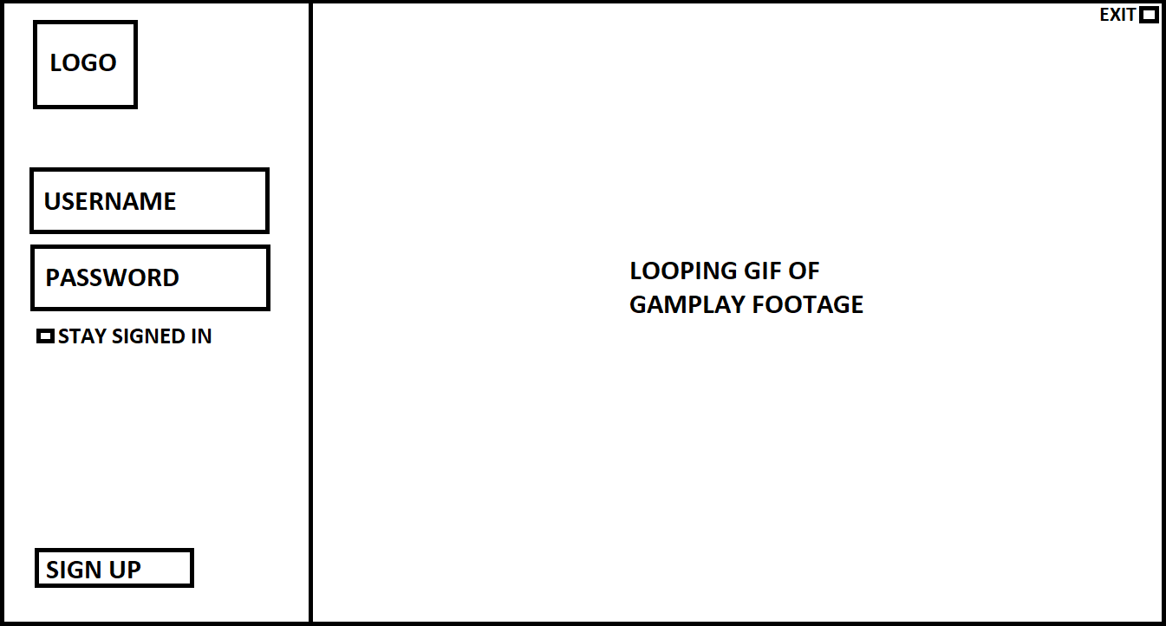

Overview:

This is the “Log in” client. The user will see this when they first open the program and will almost be a welcoming screen for players where they can log in or Signup. Having a login client separate from the game client shows a sense of profession and high quality. Generally, a lot of larger games tend to have a login client separate such as League of Legends.

Design:

Choosing a design and theme for the client is important and gives off an impression the players especially new players. I have decided to have a light and dark theme which helps clarity and generally represents high quality in comparison to a colourful client that will come off almost childish.

I intend to make the left side have a white/light grey background as this draws the attention of the players to that section of the client. I have chosen the text to be a dark grey for a couple of reasons that are as follows: black is generally quite harsh on the eyes especially with a light background, however I wanted a dark colour as my text colour to increase clarity as the background will be a contrasting lighter colour, so my final choice was a dark colour that wasn’t harsh on the eyes: a dark grey. Throughout this client, I will be using the font “Garamond” that I stumbled upon, it looks smart and clean while also being easy to read which is a perfect fit for my current theme.

Similar to the website I am designing, I will have a gif of loop gameplay footage on the right-hand side to almost show off what you should be expecting and to keep players interested while the login process takes place.

This display technique has been used in many other games and has had a lot of good reviews and success and I am keen to implement it into my product. As mentioned before, League of legends has this approach with their client which I have used and love.

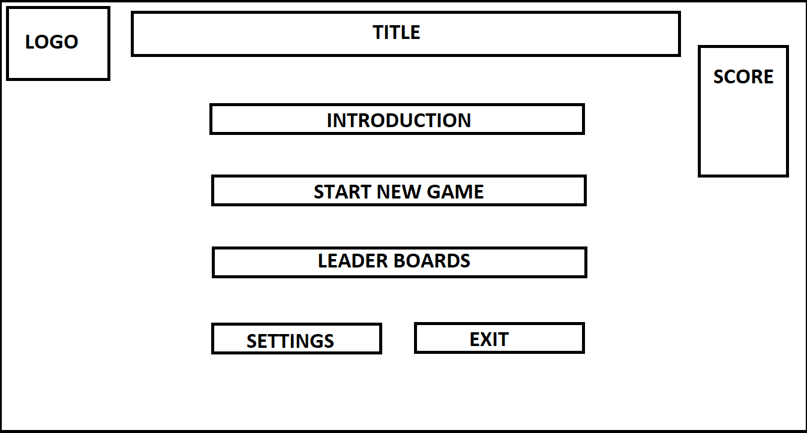**Main Menu Prototype:**

Overview:

This is the main “Main Menu”. The user will see this when they have logged into the game by using the Login Client. Players will be able to navigate the main menu to choose from the following selections: An introduction to get a sense of the game, start a new game: single-player or two-player, look at the leader boards to compare against others, settings for configuration and exit. As shown above, it will also show my logo in the top left, the title across the top and best personal score to reference to and aim to beat. Generally, this is a common approach to a main menu and has been seen in many successful games such as Minecraft.

Design

As the main menu has a generic layout, the design I decide to implement will be very important as it will allow players to distinguish my product from others, almost like a trademark such as Minecraft's' classic main menu design. In comparison to the Login page, I have decided to go with a dark and white theme again, however switching the background and texts: having the background to be dark and the text to be a lighter colour. I have decided to do this as the main menu will be where players may spend a lot of time check scores etc. So having a light background may be straining. I aim to have a simple main menu that is fully functioning letting players almost sit there and take it all in just like I and many others did with the popular game "Halo Reach" which had a great soundtrack as well as a relaxing background.

I have chosen the text to be a light grey, along with the buttons being a little darker version of the text. As mentioned before with the login client, black is too harsh of a colour so I will be using a dark grey as the background. Again, I will be using the font “Garamond” as it looks smart and clean while also being easy to read.

As mentioned previously, games such as “Minecraft” and “Halo Reach” have been able to pull this design off perfectly and I aim to use them as a reference point.

**Game Client Breakdown**

**Introduction Prototype:**

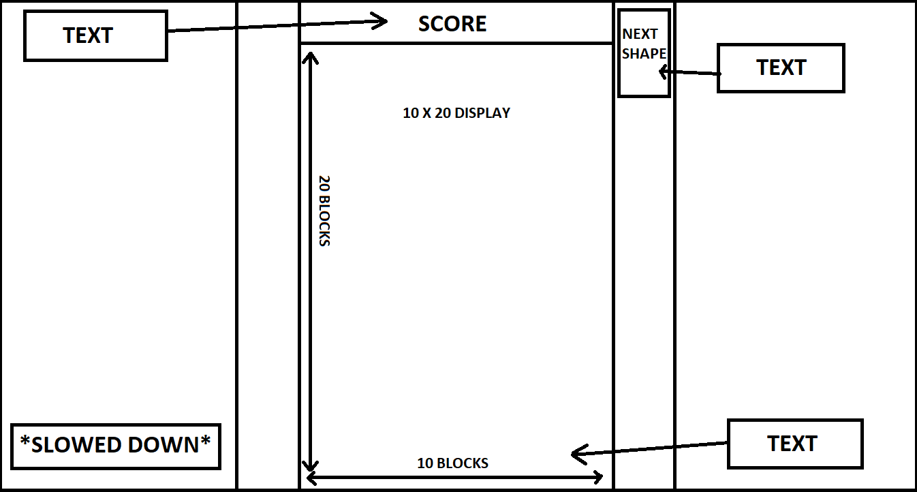

Overview:

This is the main “Introduction”. Simply put, it is a tutorial to let the player get a sense of how the game works and the controls. I have researched key points to keep in mind when making an introduction for a game, here is what I have learnt: a slowed-down experience to allow the player to not get overwhelmed, short bursts of text illustrating what each part is e.g. the Score, as shown above, interactive section that allows the player to get a feel for the game themselves. From this research and personal experience, I have concluded this is the best way to introduce a Tetris like game to someone. Game developers often use too much text and over-complicate situations leading the player to skip the tutorial altogether.

Design:

This will only be a tester for the player and will not show off all the features that are included in the main game as it's a setup environment to allow the player to learn the game. Therefore to make up for the lack of features, such as themes, I will have a theme tune that will be playing in the background to keep the players interested. Once the player has had enough of the introduction, the may exit and move onto single player or 2 player if they feel like they know how the game works. I will be introducing each piece of text information one at a time to not overwhelm the player. Again I will have a contrasting theme between the text and the background that it is displayed on to help any clarity issues. I will keep the theme basic in the introduction to, again, not overwhelm the player. Throughout the game, I will be using the font “Garamond”.

This approach is popular and is tend to be used a lot, however with my extra research and personal experience I hope to not make any of the mistakes some game developers make of leaving players overwhelmed with information.

**Start New Game – Single Player Prototype:**

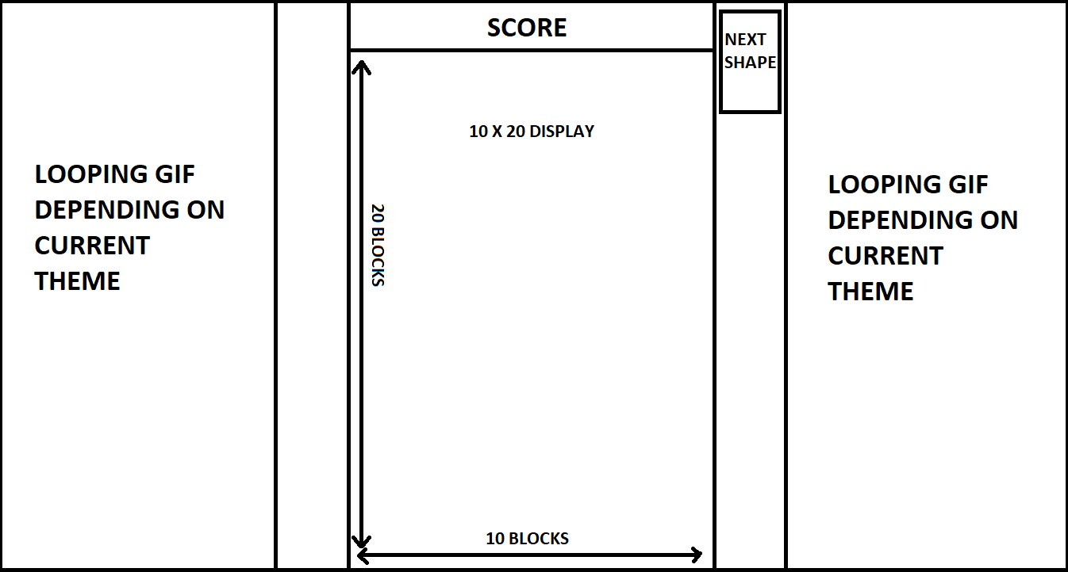

Overview:

This is the single-player arena where a player will play on their own to compete against their previous best score or other players' best scores. New players who have moved on from introduction will most likely start off playing single player now they know how the game works. The average player will most likely spend most of their game time on this section and as shown above, I am aiming to include some features that will boost the player experience such as themes that get unlocked once you reach a certain score, a scoreboard, next shape and each row of blocks.

Design:

Single-player will only have 1 arena allowing for more space in comparison to two-player having 2 arenas. This allows me to set up, as mentioned earlier, a theme system (which I will go into more detail at the end of the design breakdowns), a soundtrack and a vibrant colour block system. In comparison to the introduction, all features will be present, such as themes, soundtracks linked with themes, coloured theme in the block section.

I will be using the “Garamond” font as previously mentioned for its smart and clean look while also being easy to read. The only text that will be present will be “Score” and “Next Shape”, I will have the font colour to be a vibrant colour depending on what theme is currently playing. In comparison to other parts of my product, I aim for the single-player and two-player to be more vibrant and colourful, as this is what makes Tetris what it is.

Tetris games and other colourful games such as candy crush etc. have a lot of colours everywhere which is appealing to the younger age group that will be part of my target audience. It also shows a sense of casual gaming while maintaining the competitive feel I aim to achieve.

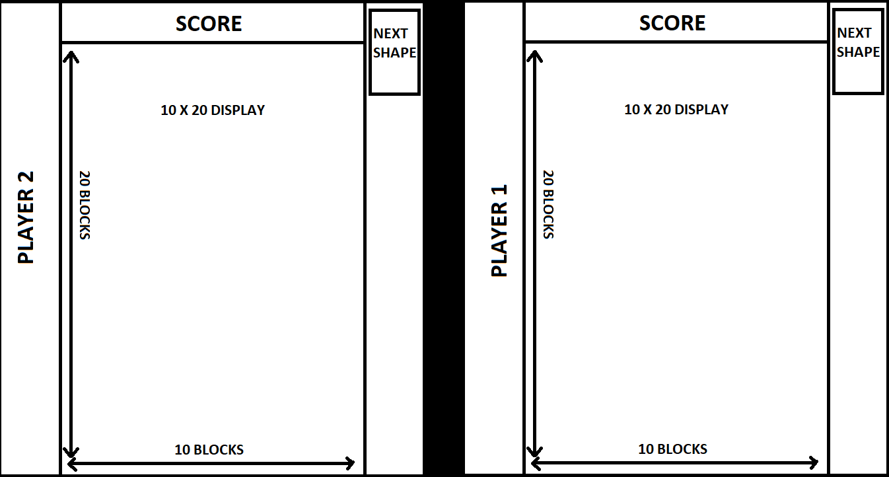**Start New Game – Two-Player Prototype:**

Overview:

This is the Two-Player arena where two players will play against each other competing on who will have a higher score. I aim to have this game mode be the most competitive and intense, bringing on a different atmosphere to most casual games. Player1 will have their score recorded, however, player2 will play as a guest. Unfortunately, having two separate logins overcomplicates the login system, if two separate logins are attempted on a single computer.

Design:

In comparison to Single-player, Two-Player will have 2 arenas which does not allow for themes, so there will be a bar down the middle that will flash whenever someone clears a row. However, there will be a soundtrack playing in the background that will change depending on the sum of scores and a vibrant colour block system will still be in place.

I will still be using the “Garamond” font as previously mentioned for its smart and clean look while also being easy to read. The only text that will be present will be “Score”, “Next Shape”, “Player1” and “Player2”. I will have the font colour for these words to be a vibrant colour depending on what soundtrack is currently playing.

I am thinking of adding in animations such as fire etc. but I am currently unsure whether or not this will cause the player to be overwhelmed from too much going on.

**Leader boards Prototype:**

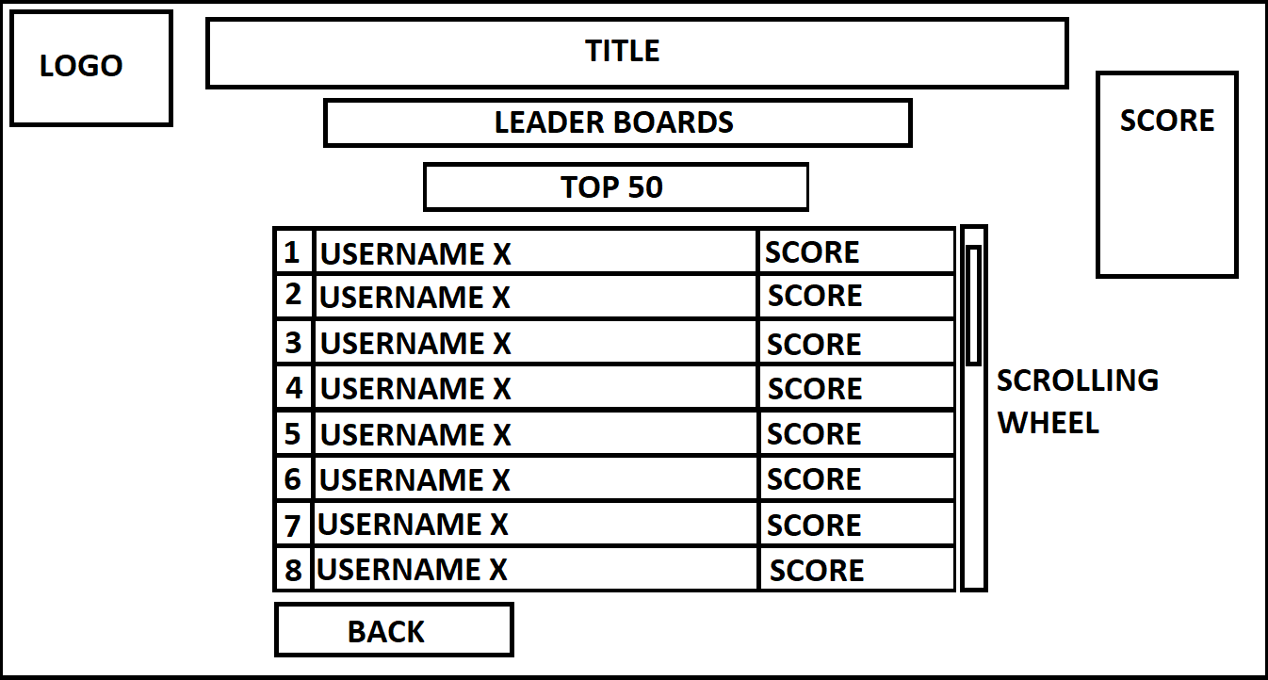

Overview:

The leader boards can be accessed from the main menu and it is where players can reflect and compare their current top score to other players and friends. The leader boards will show the “Top 50” players and I will write an algorithm that increases it depending on how many players there are.

Design:

The design will have the same theme as the main menu: Dark grey background with light grey text and mid-grey buttons, using the font "Garamond". I have chosen to continue the theme as it is a branch off the main menu so it wouldn't make sense to change the theme. There will be a scrolling wheel that players can use the view the list of players on the leader boards. The player's name will be highlighted for them and them only to increase clarity and so the player can locate where they are on the list.

This is a common approach to leader boards and I believe that it is very clear and high quality and from personal experience, it is what I would want the leader boards to look like. “Overwatch” has achieved this with success. The game developers have created a clear leader boards system indicating where you are and a scroll wheel allowing you to scroll to view the list so I have used their system as a reference.

**Settings Prototype:**

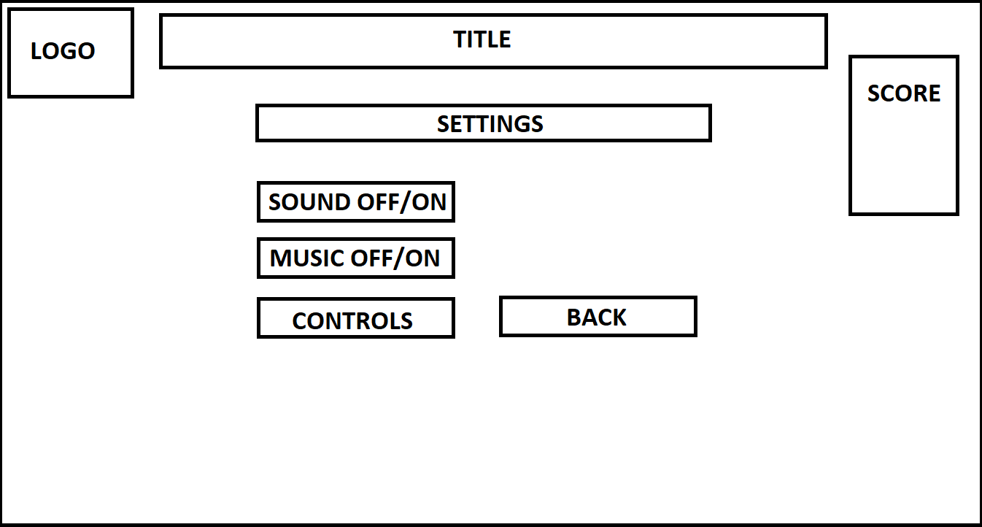

Overview:

“Settings” can be accessed from the main menu and it is where players can configure options such as turning sound off/on or music off/on as well as controls. This is quite a basic approach to a settings tab however, my game is a simple game and doesn’t require such in-depth settings that games such as “GTAV” etc. have.

Design:

The design will have the same theme as the main menu: Dark grey background with light grey text and mid-grey buttons, using the font "Garamond". I have chosen to continue the theme as settings is a branch off the main menu so it wouldn’t make sense to change the theme.

This is a common approach to settings for smaller games and I believe that it is very clear and achieves what it was made to do. As mentioned, smaller indie games with lower requirements generally have a smaller selection of preferences to select from.

**Controls Prototype:**

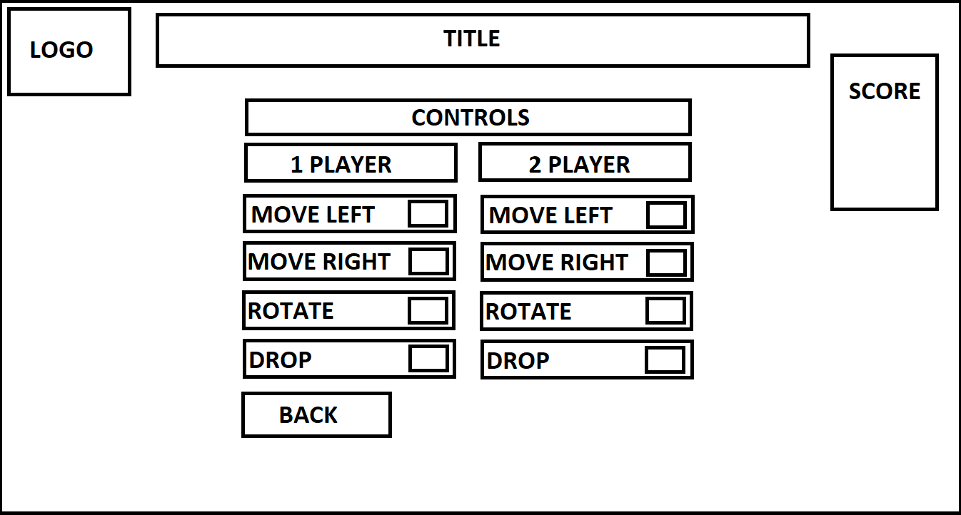

Overview:

“Controls” can be accessed from the “Settings” menu and it is where players can configure controls such movement, rotation and drop. Both players can change what they want to use.

Design

The design will have the same theme as the main menu: Dark grey background with light grey text and mid-grey buttons, using the font "Garamond". I have chosen to continue the theme as controls is a continuation from the Settings so it wouldn’t make sense to change the theme.

As this game has few controls, the controls page is small in comparison to many other games. Similar smaller games tend to have a small selection of controls such as “Castle Crashers”.

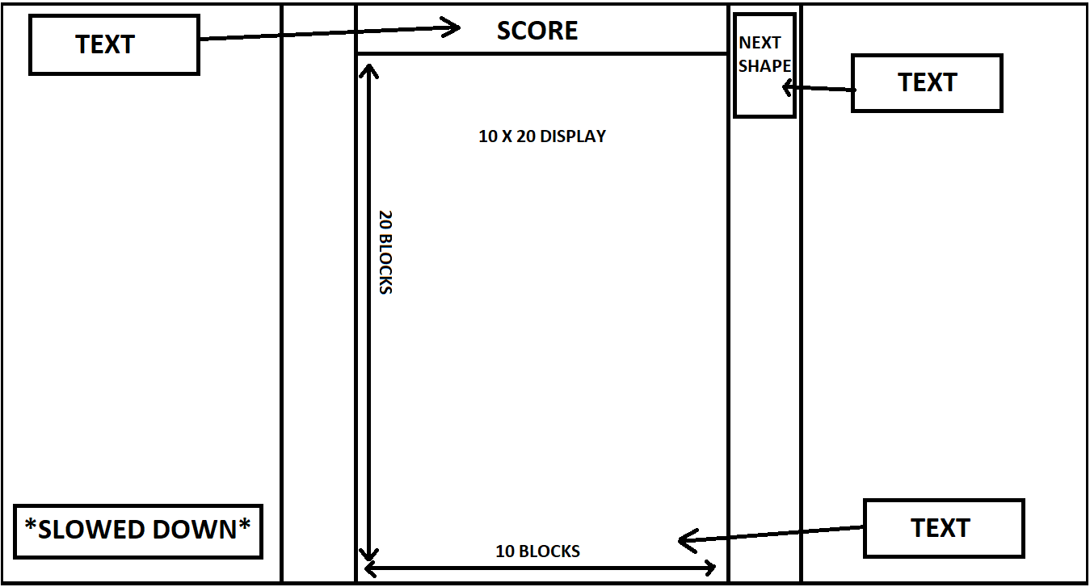**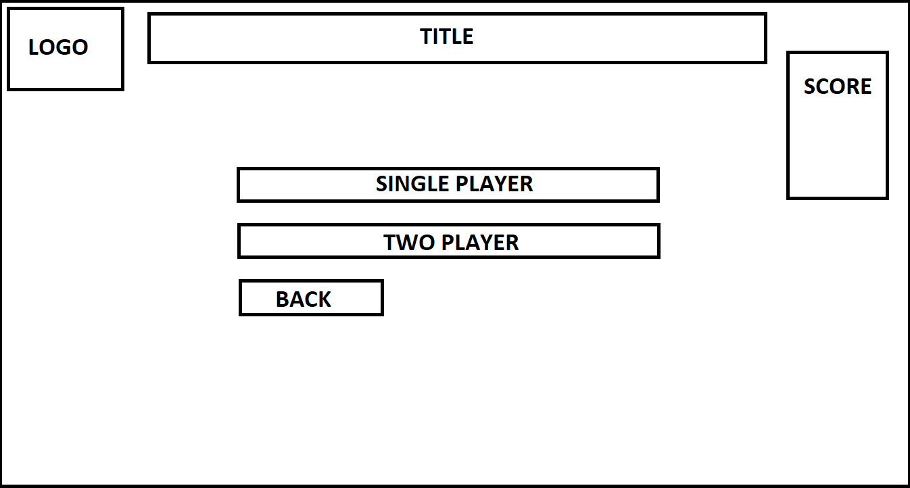New Game**

Overview:

After selecting "New Game", players will be directed to this page where they can select whether they would like to enter a single-player arena or two-player arenas.

Design:

The design will have the same theme as the main menu: Dark grey background with light grey text and mid-grey buttons, using the font "Garamond". I have chosen to continue the theme as controls is a continuation from the Settings so it wouldn't make sense to change the theme.

**In-depth explanation:**

**Themes:**

I intend to design special themes that will infinitely loop until the player reaches the next checkpoint e.g. a water theme will loop until they reach a certain score where the sky theme will then take over. "Jump King" has achieved this flawlessly, the themes are interesting and the quality of each theme has been revised to perfection, leaving players excited to see what mysterious theme could be next. I also aim to have a music theme tune that will change depending on themes to keep players engaged and to discourage any feelings of repetitiveness that may come from casual games. Overall, I believe themes will generally boost the quality of each players experience while also greatly increasing the replayability.

**Stakeholder Input**

At this point, I have a good idea of how my final product/game will look with analysis linked to each image. I have had a meeting with the stakeholders to make sure it is what they required to see if they had any further input.

**I sent them the following emails:**

**Email 1**

“Hi,

I've been looking at ways I can make the software UI and I have come up with some specific ideas and plans I may implement, and I would appreciate your input. When the game starts, it will open up a screen with a size of 1280 x 720. It will ask for you to sign in or sign up if you haven't. Once signed in, you will be greeted with the main menu where the following buttons will be: Introduction, New Game (which will split into Single and 2 player), Leader boards, Settings, and Exit. It will also have your score displayed on the side. The system requirements for this game are very minimal and shouldn’t need to be considered. What do you think?

Thanks,

Younis”

**The responses I received:**

**Marce:**

“”

**Daniel:**

“When you say your score is displayed on the side, what do you mean? Score for what? Is it a high-score? Aside from that, I think these are useful things to have on a landing page. Will there be anything else displayed when you first load the game aside from sign in/sign up? If so, what would it be?

Kind regards,

Your faithful companion Daniel.”

**Marce:**

“”

**Email 2**

“Hi,

I’ve created some prototype images of how the game will look and I have linked a small analysis which includes an overview and design to all of the images. I have made it very user-friendly and have implemented anything I thought would be beneficial to the user experience. I plan on adding to these as they are only prototypes, do you have any suggestions or anything you wish to be added?

Thanks,

Younis”

**Marce:**

“”

**Daniel:**

“When you say your score is displayed on the side, what do you mean? Score for what? Is it a high-score? Aside from that, I think these are useful things to have on a landing page. Will there be anything else displayed when you first load the game aside from sign in/sign up? If so, what would it be?

Kind regards,

Your faithful companion Daniel.”

**Algorithms**

Reference:

Tetris 99: <https://en.wikipedia.org/wiki/Tetris_99>, <https://uk.ign.com/articles/2019/02/20/tetris-99-review>